___________________________________________________________________________

*Faculty of Information Technology and Engineering*

*Electrical Circuit Lab*

|  |  |
| --- | --- |
| Students ID: 202110795, 202112300 | Students Name: Sama Haitham Sammar, Arein Zaid |
| Experiment #: 8 | Experiment Name: Impedance and Sinusoidal Steady State |
| Section: 3 | Supervisor Name: Dr Amjad Abu Jazar |
| Date: 6 June 2024 | Day: Thursday |

***Objective:***

1. Examine the frequency dependent behavior of impedance.
2. Examine the sinusoidal steady-state response of RL, RC and RLC circuits.
3. Measuring of self-inductance and capacitance.

***Apparatus Required:***

* Digital Multimeter.
* Signal Generator.
* Oscilloscope.
* Components (Resistors, Capacitors, Inductors, Cables and Breadboard).

***Experiment Procedure:***

***Part One: RC circuit and RL circuit.***

1. **Connect the circuit shown below with Vin = 3.5 VRMS**



Figure 1

1. **Using Digital Multimeter, measure the RMS voltages |Vin|, |VR|, and |VC| for the different frequencies and tabulate your results in Table (1).**
2. **Calculate the current of the circuit |I|, the impedances |ZC| and |Zin| for the different frequencies and tabulate your results in Table (1).**
3. **Using the oscilloscope, measure the phase shift between the input voltage and the input current for the different frequencies and tabulate your results in Table (1).**

**Table (1):**

|  |  |  |  |  |  |  |  |  |  |  |
| --- | --- | --- | --- | --- | --- | --- | --- | --- | --- | --- |
| **Freq.**  **(Hz)** | **|Vin|**  **By Multisim** | **|Vin|**  **on Lab** | **|VR|**  **By Multisim** | **|VR|**  **on Lab** | **|VC|**  **By Multisim** | **|VC|**  **on Lab** | **|I|=|VR|/R**  **on Lab** | **|ZC|= |VC|/|I|**  **on Lab** | **|Zin|= |Vin|/|I|**  **on Lab** | **Ө**  (o)  **on Lab** |
| **500** |  |  |  |  |  |  |  |  |  |  |
| **1k** |  |  |  |  |  |  |  |  |  |  |
| **2k** |  |  |  |  |  |  |  |  |  |  |
| **5k** |  |  |  |  |  |  |  |  |  |  |
| **10k** |  |  |  |  |  |  |  |  |  |  |
| **30k** |  |  |  |  |  |  |  |  |  |  |

1. **Connect the circuit shown below with Vin = 3.5 VRMS.**



Figure 2

1. **Using Digital Multimeter, measure the RMS voltages |Vin|, |VR|, and |VL| for the different frequencies and tabulate your results in Table (2).**
2. **Calculate the current of the circuit |I|, the impedances |ZL| and |Zin| for the different frequencies and tabulate your results in Table (2).**
3. **Using the oscilloscope, measure the phase shift between the input voltage and the input current for the different frequencies and tabulate your results in Table (2).**

**Table (2):**

|  |  |  |  |  |  |  |  |  |  |  |
| --- | --- | --- | --- | --- | --- | --- | --- | --- | --- | --- |
| **Freq.**  **(Hz)** | **|Vin|**  **By Multisim** | **|Vin|**  **on Lab** | **|VR|**  **By Multisim** | **|VR|**  **on Lab** | **|VL|**  **By Multisim** | **|VL|**  **on Lab** | **|I|=|VR|/R**  **on Lab** | **|ZL|= |VL|/|I|**  **on Lab** | **|Zin|= |Vin|/|I|**  **on Lab** | **Ө**  (o)  **on Lab** |
| **500** | 3.5v | 3.53v | 2.414v | 2.21v | 2.534v | 1.75v | 2.21mA | 0.7918k | 1.597k | 27.9 |
| **1k** | 3.5v | 3.66v | 1.505v | 1.85v | 3.16v | 2.88v | 1.85mA | 1.5567k | 1.978k | 44.2 |
| **2k** | 3.5v | 3.77v | 811.017mv | 1.25v | 3.405v | 3.48v | 1.25mA | 2.784k | 3.016k | 51.5 |
| **5k** | 3.5v | 3.97v | 331.976mv | 605mv | 3.484v | 3.98v | 0.605mA | 6.5785k | 6.562k | 82.5 |
| **10k** | 3.5v | 4.08v | 166.553mv | 353mv | 3.496v | 4.04v | 0.353mA | 11.4447k | 11.558k | 74.5 |
| **30k** | 3.5v | 4.1v | 55.573mv | 268mv | 3.5v | 4.08v | 0.268mA | 15.2238k | 15.298k | 88.3 |

**Vin leads VR**

**500Hz**

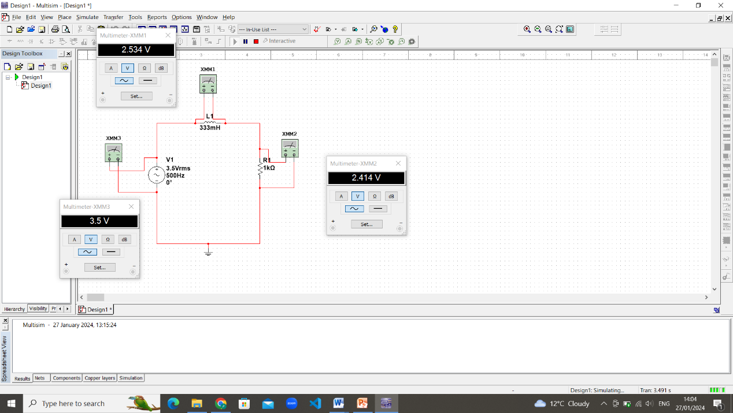

**1KHz**

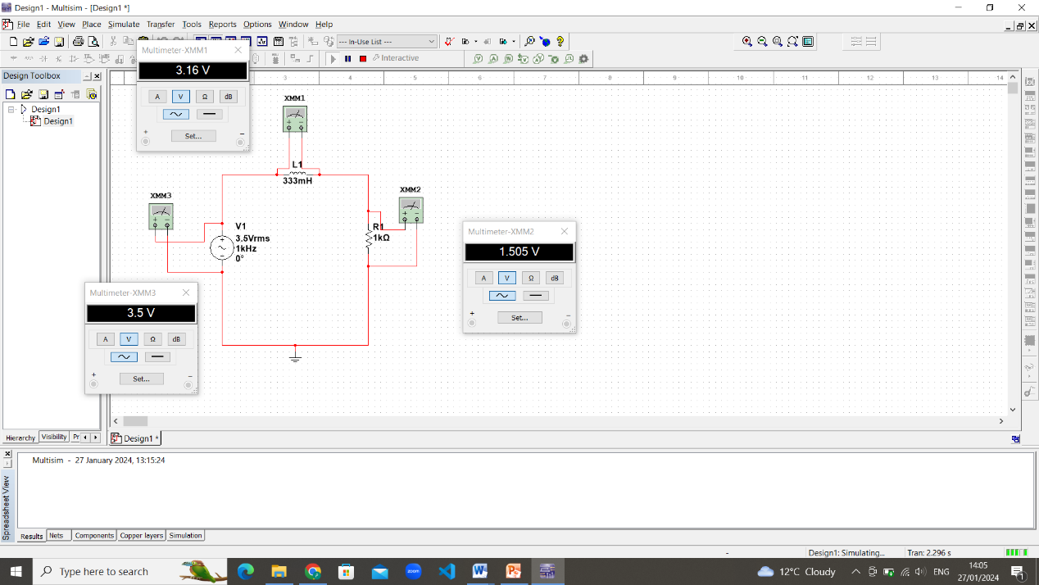

**2KHz**

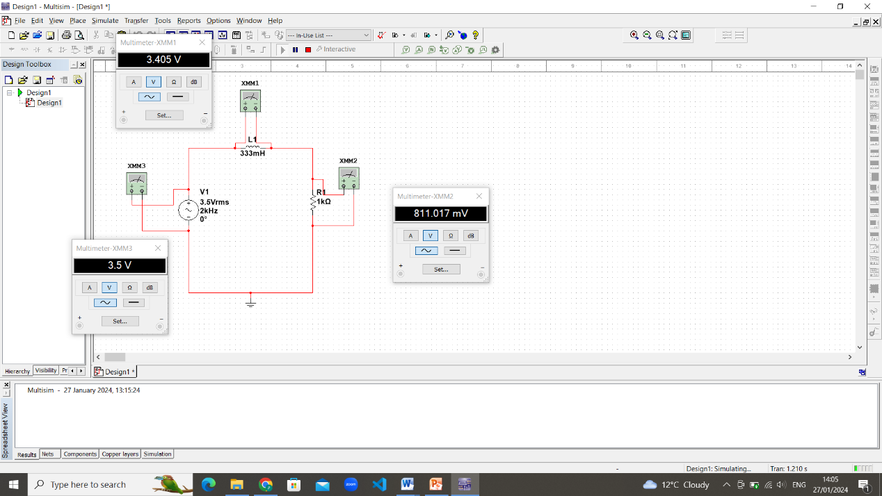

**5KHz**

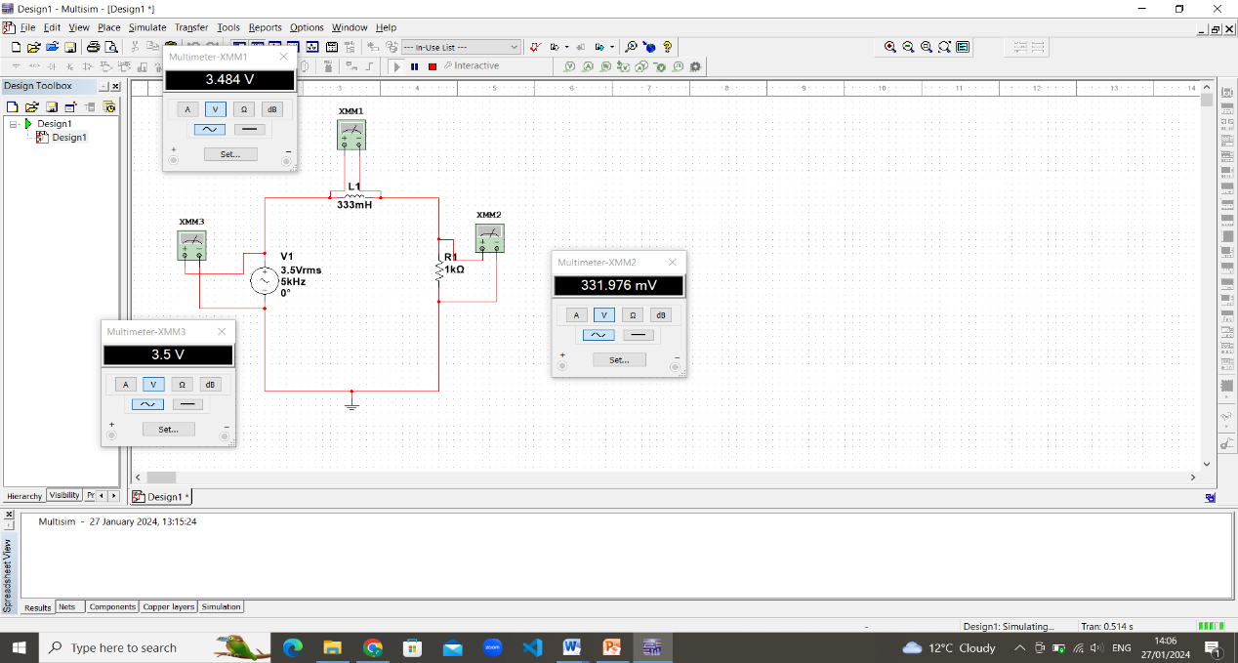

**10KHz**

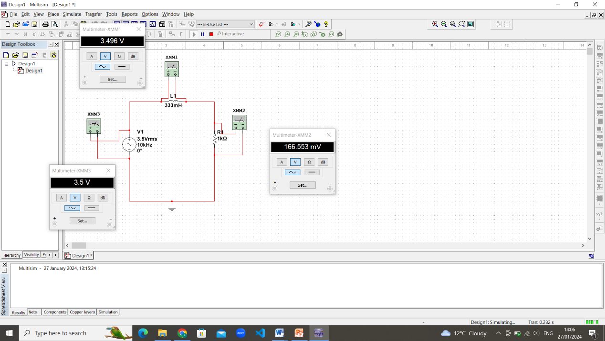

**30KHz**

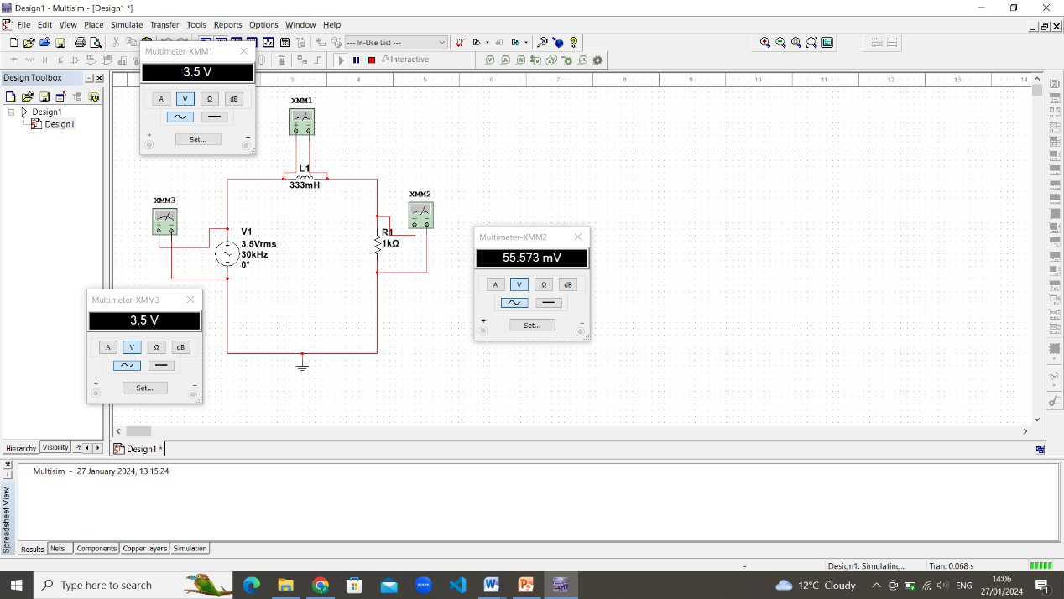

**Vin:**

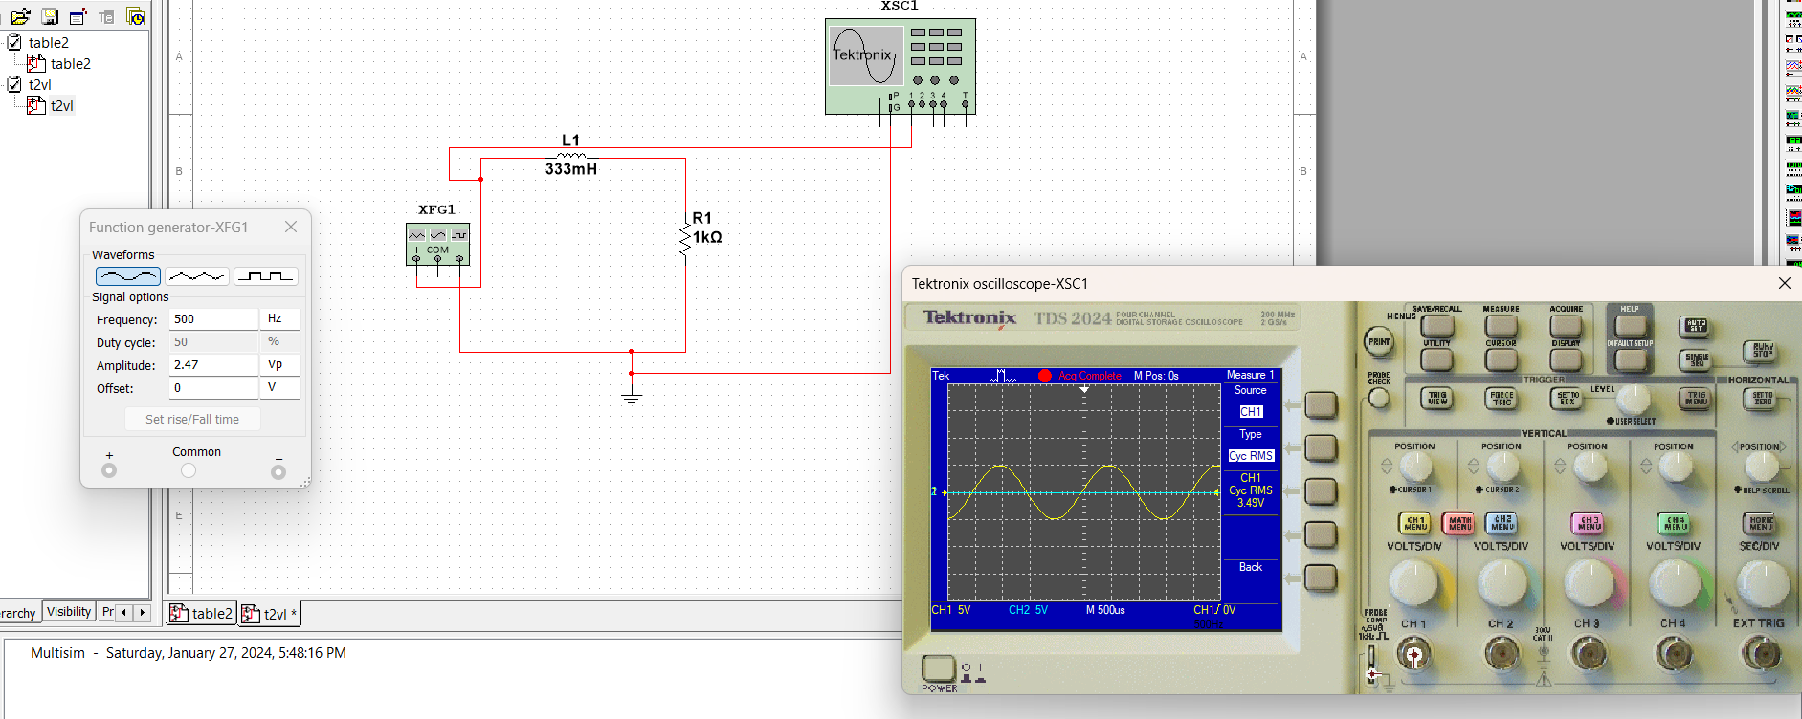

**VR:**

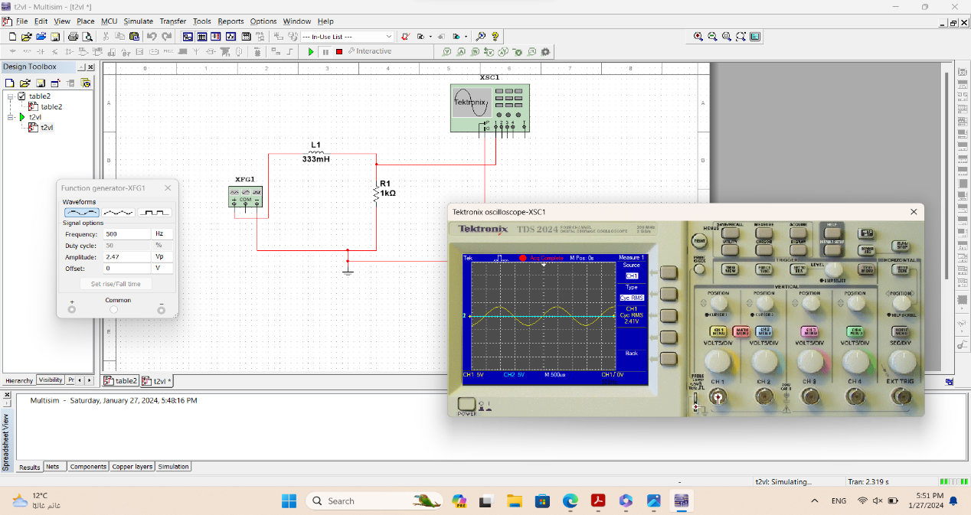

**VL:**

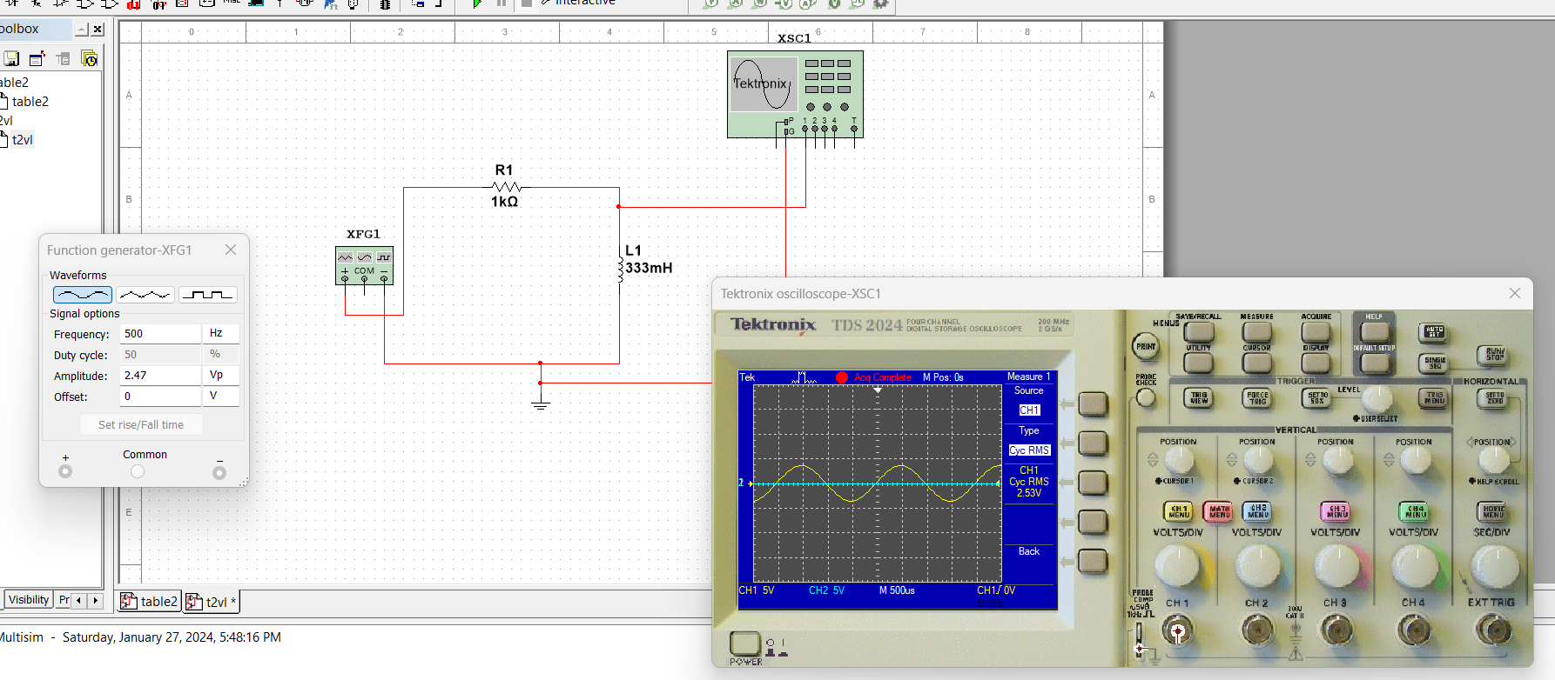

This from the lab the phase 500Hz

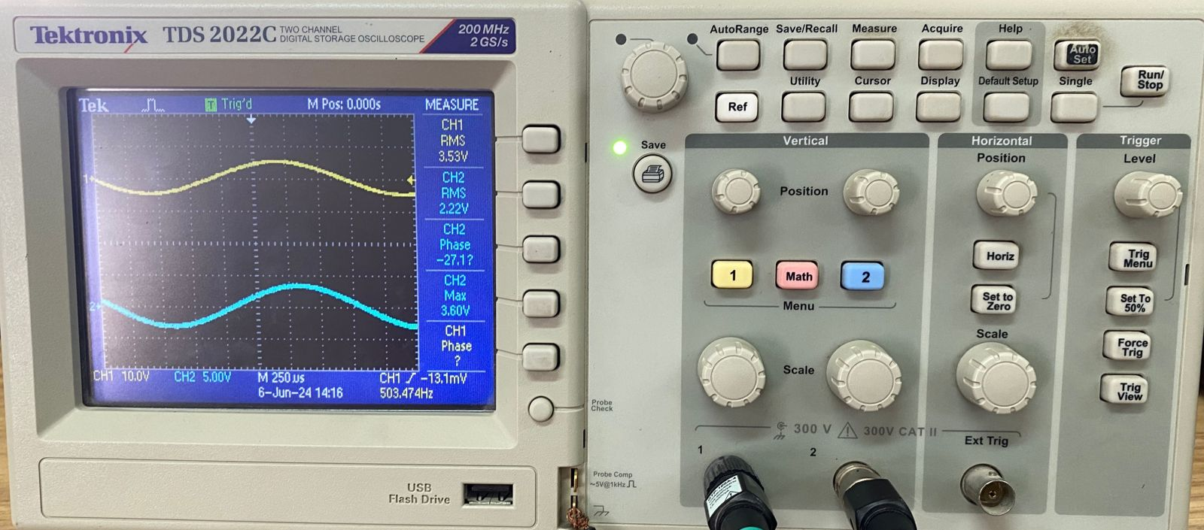

***Part Two: RLC circuit.***

1. **Connect the circuit shown below with Vin = 3.5 VRMS**



Figure 3

1. **Using Digital Multimeter, measure the RMS voltages |Vin|, |VR|, |VL|, and |VC| for the different frequencies and tabulate your results in Table (3).**
2. **Calculate the current of the circuit |I| and the impedance |Zin| for the different frequencies and tabulate your results in Table (3).**
3. **Using the oscilloscope, measure the phase shift between the input voltage and the input current for the different frequencies and tabulate your results in Table (3).**

**Table (3):**

|  |  |  |  |  |  |  |  |  |  |  |
| --- | --- | --- | --- | --- | --- | --- | --- | --- | --- | --- |
| **Freq.**  **(Hz)** | **|Vin|**  **on Lab** | **|VR|**  **By Multisim** | **|VR|**  **on Lab** | **|VL|**  **By Multisim** | **|VL|**  **on Lab** | **|VC|**  **By Multisim** | **|VC|**  **on Lab** | **|I|=|VR|/R**  **on Lab** | **|Zin|= |Vin|/|I|**  **on Lab** | **Ө**  (o)  **on Lab** |
| **500** | 3.57v | 404.311 mV | 416mv | 423.006 mV | 337mv | 3.9 V | 3.62v | 0.416mA | 8.5817k | 80.8 |
| **1k** | 3.66v | 1.204 V | 1.22v | 2.521 V | 1.55v | 5.807 V | 5.00v | 1.22mA | 3k | 62.7 |
| **2k** | 3.73v | 1.713 V | 2.10v | 7.177 V | 7.03v | 4.125 V | 5.57v | 2.1mA | 1.7762k | 17.4 |
| **5k** | 3.93v | 362.927 mV | 685mv | 3.828 V | 4.46v | 347.187 mV | 673mv | 0.685mA | 5.7372k | 72.8 |
| **10k** | 3.98v | 168.719 mV | 323mv | 3.576 V | 4.12v | 80.323 mV | 206mv | 0.323mA | 12.3219k | 80.8 |
| **30k** | 3.98v | 55.17 mV | 101mv | 3.508 V | 4.03v | 8.755 mV | 146mv | 0.101mA | 39.4059k | 89.4 |

**Vin leads VR**

**500Hz**

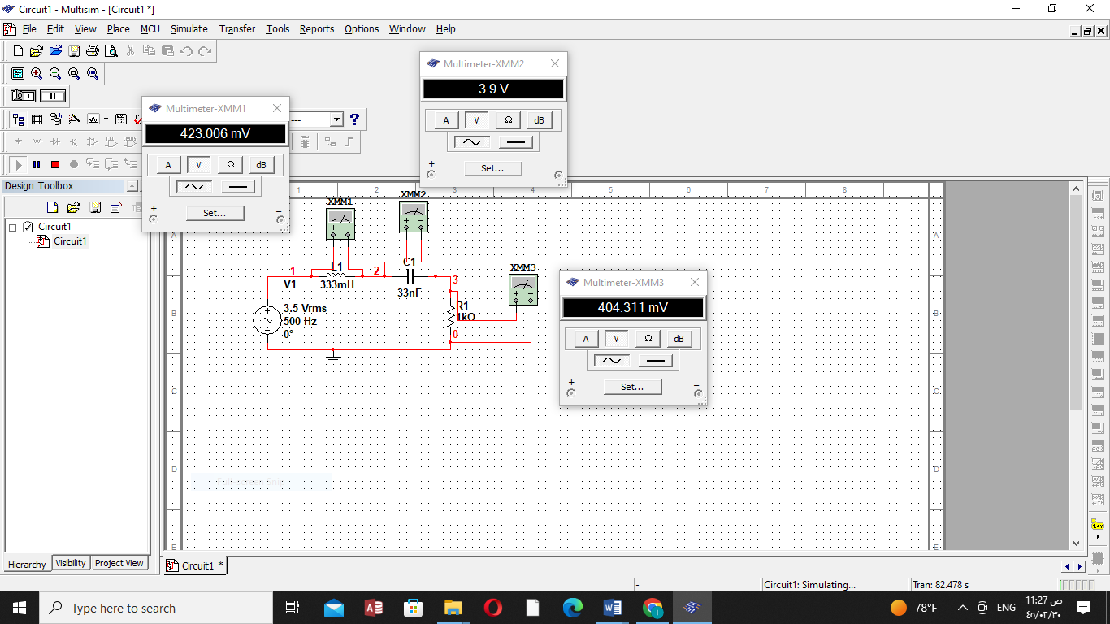

**1KHz**

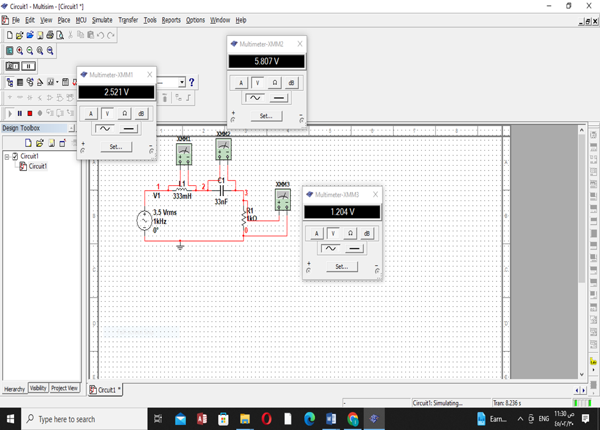

**2KHz**

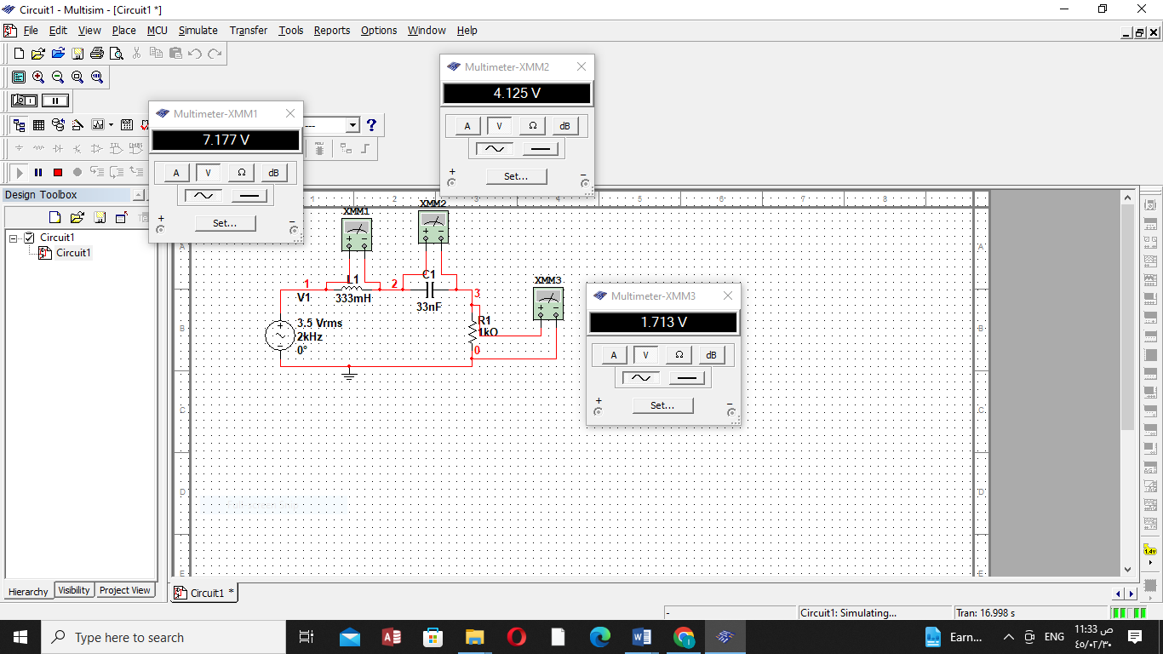

**5KHz**

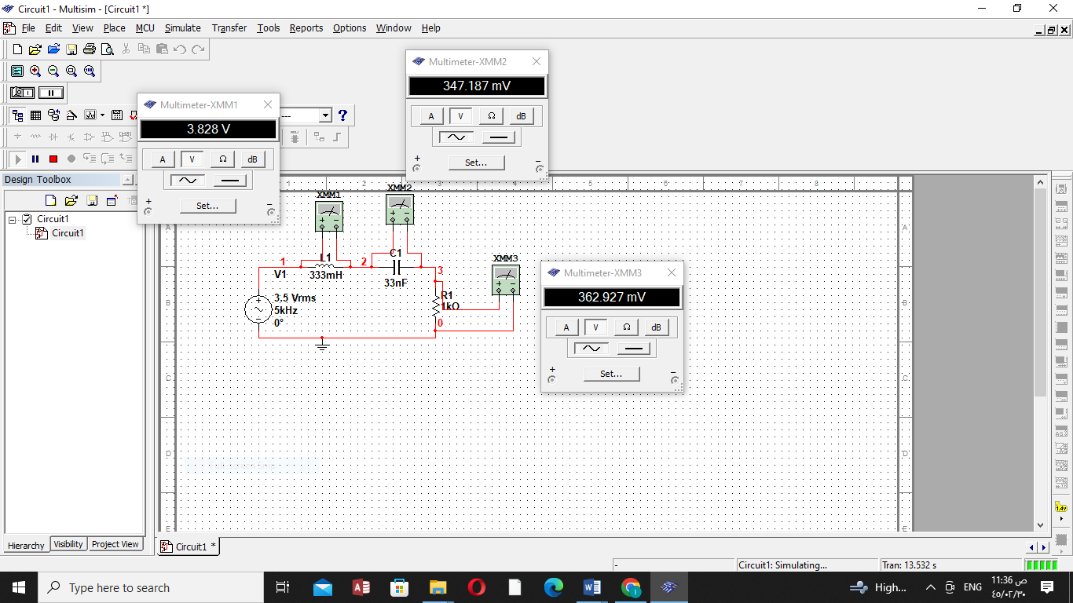

**10KHz**

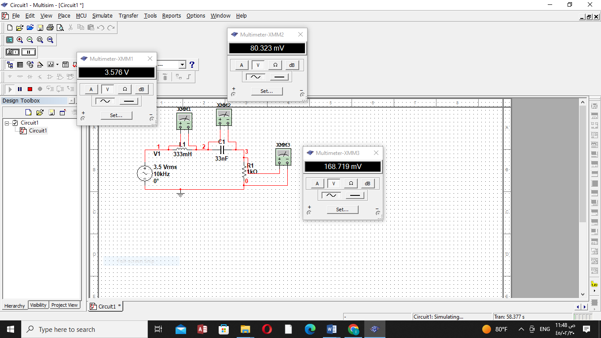

**30KHz**

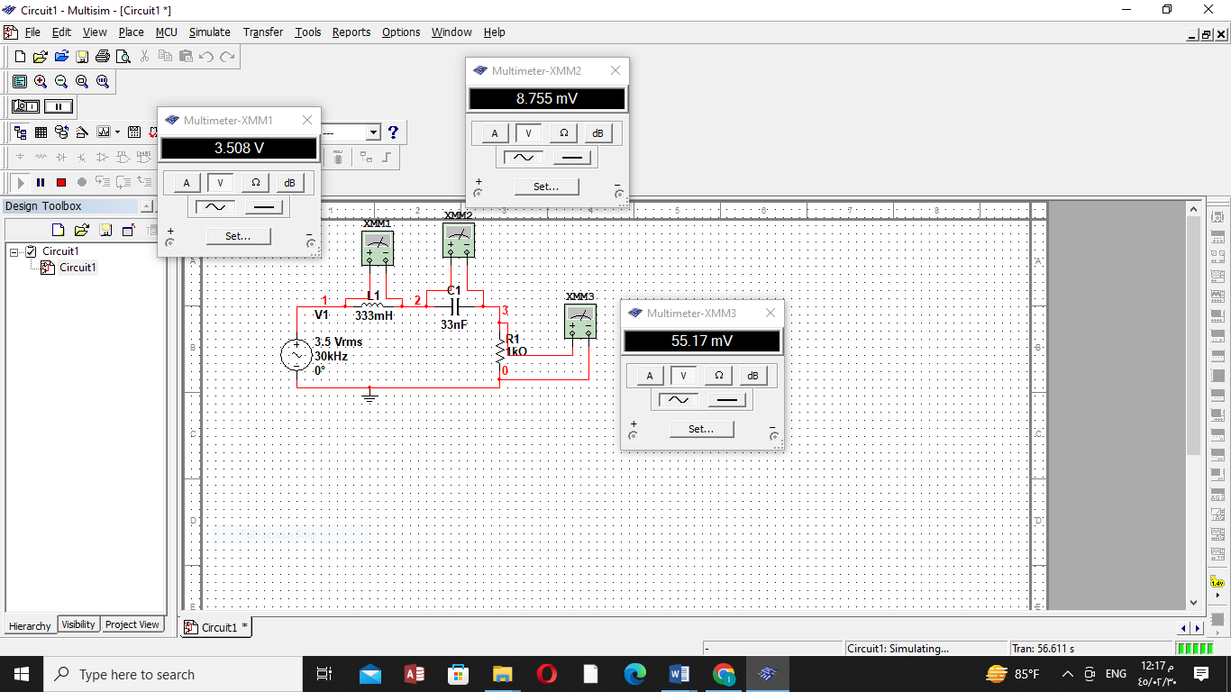

**Vin:**

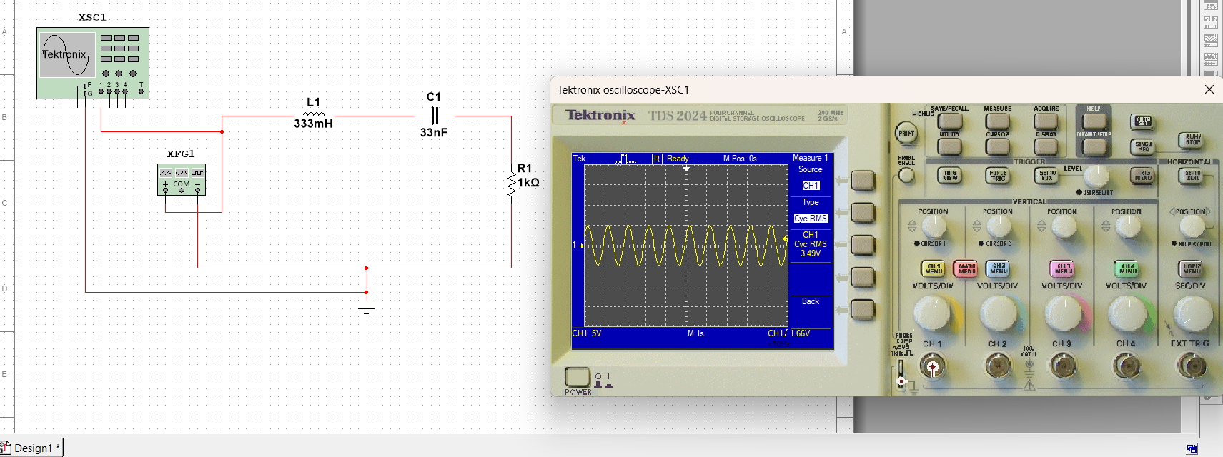

**VR:**

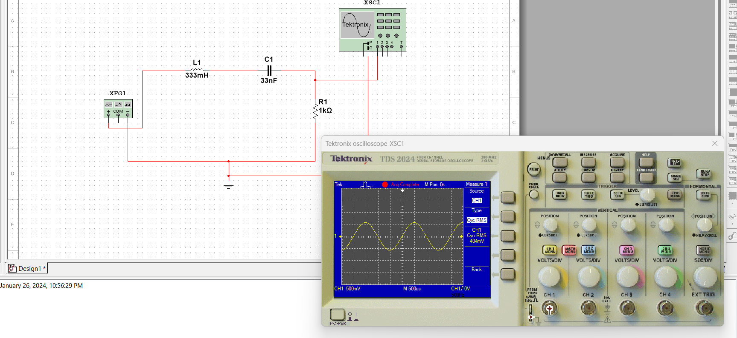

**VC:**

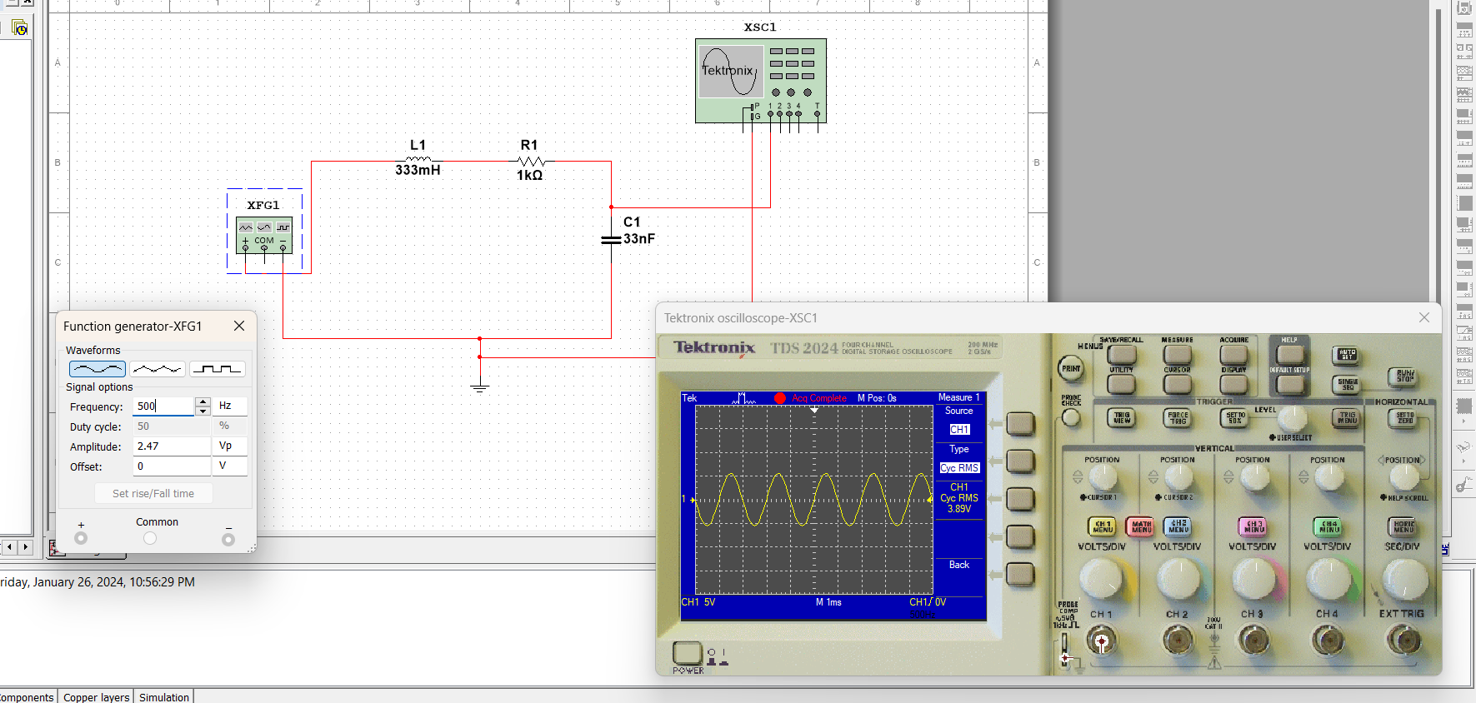

**VL:**

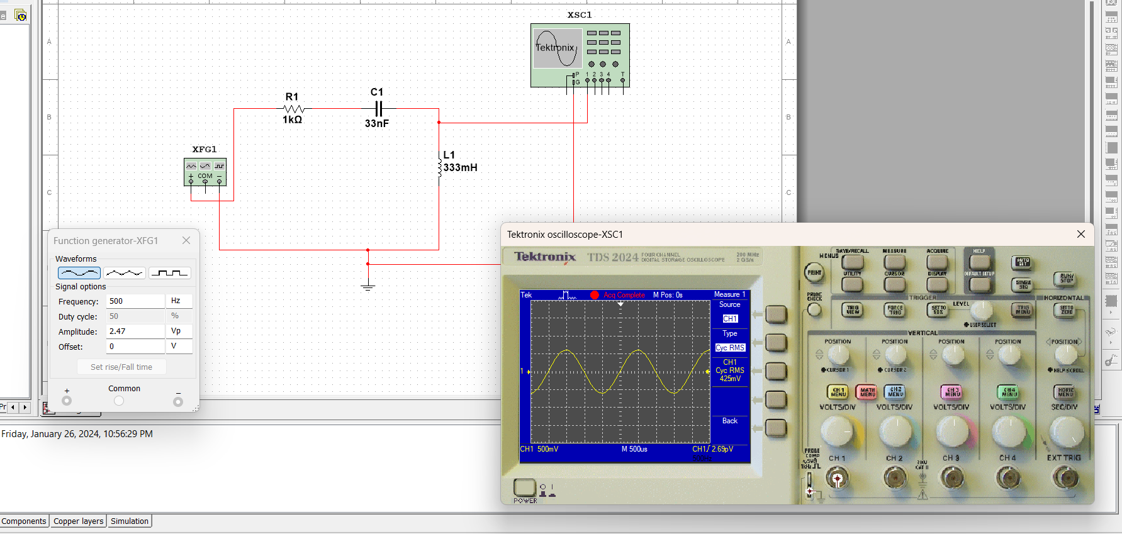

1. **Connect the circuit shown below with Vin = 3.5 VRMS.**



Figure 4

1. **Using Digital Multimeter, measure the RMS voltages |Vin|, |VR|, |VL|, and |VC| for the different frequencies and tabulate your results in Table (4).**
2. **Calculate the current of the circuit |I| and the impedance |Zln| for the different frequencies and tabulate your results in Table (4).**
3. **Using the oscilloscope, measure the phase shift between the input voltage and the input current for the different frequencies and tabulate your results in Table (4).**

**Table (4):**

|  |  |  |  |  |  |  |  |  |  |  |
| --- | --- | --- | --- | --- | --- | --- | --- | --- | --- | --- |
| **Freq.**  **(Hz)** | **|Vin|**  **on Lab** | **|VR|**  **By Multisim** | **|VR|**  **on Lab** | **|VL|**  **By Multisim** | **|VL|**  **on Lab** | **|VC|**  **By Multisim** | **|VC|**  **on Lab** | **|I|=|VR|/R**  **on Lab** | **|Zin|= |Vin|/|I|**  **on Lab** | **Ө**  (o)  **on Lab** |
| **500** | 3.55v | 2.27 V | 2.18v | 2.664 V | 1.86v | 2.664 V | 1.86v | 2.18mA | 1.628k | 26.6 |
| **1k** | 3.7v | 913.499 mV | 1.21v | 3.379 V | 2.92v | 3.379 V | 2.92v | 3.7mA | 1k | 48.5 |
| **2k** | 3.86v | 608.613 mV | 462mv | 3.447 V | 3.61v | 3.447 V | 3.61v | 3.86mA | 1k | 62.4 |
| **5k** | 3.85v | 2.411 V | 2.7v | 2.537 V | 2.82v | 2.537 V | 2.82v | 3.85mA | 1k | 44.5 |
| **10k** | 3.8v | 3.147 V | 3.55v | 1.532 V | 1.66v | 1.532 V | 1.66v | 3.8mA | 1k | 25.1 |
| **30k** | 3.9v | 3.456 V | 3.88v | 549.869 mV | 586mv | 549.869 mV | 586mv | 3.9mA | 1k | 9.53 |

**Vin leads VR**

**500Hz**

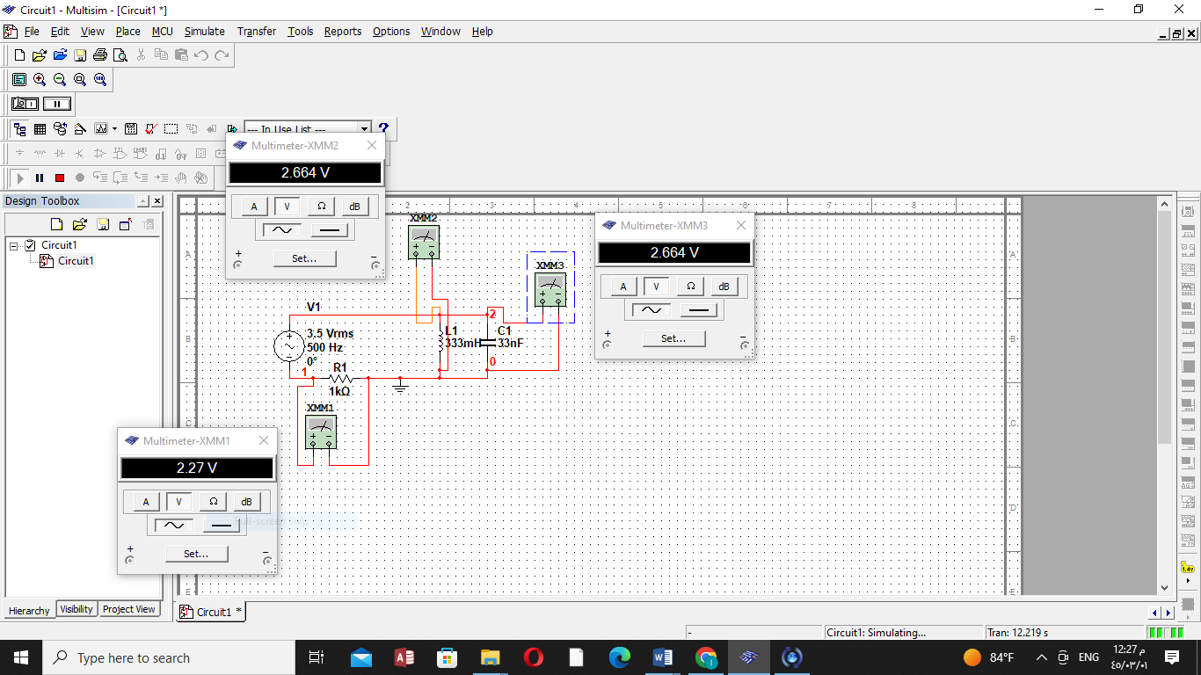

**1KHz**

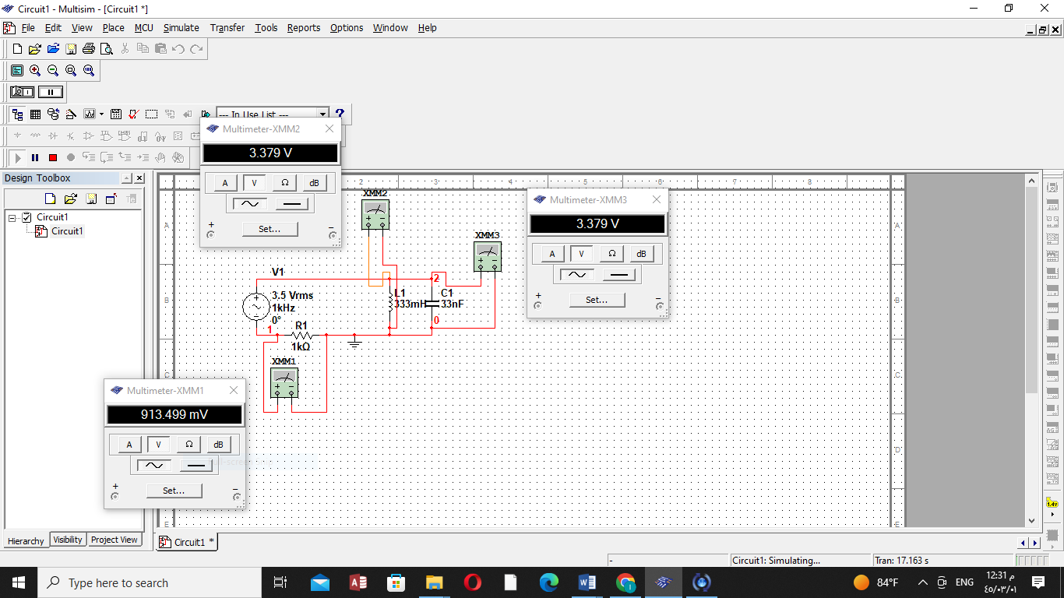

**2KHz**

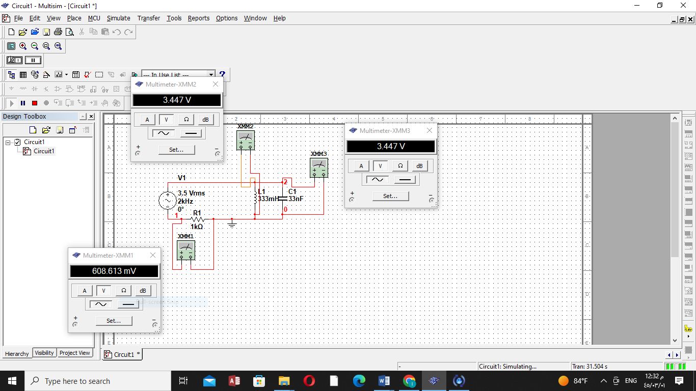

**5KHz**

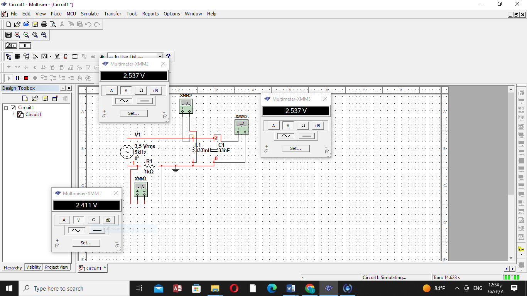

**10KHz**

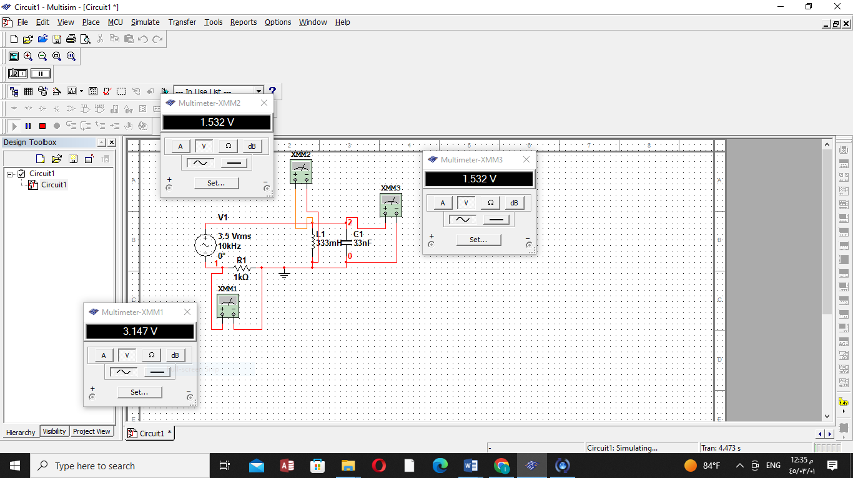

**30KHz**

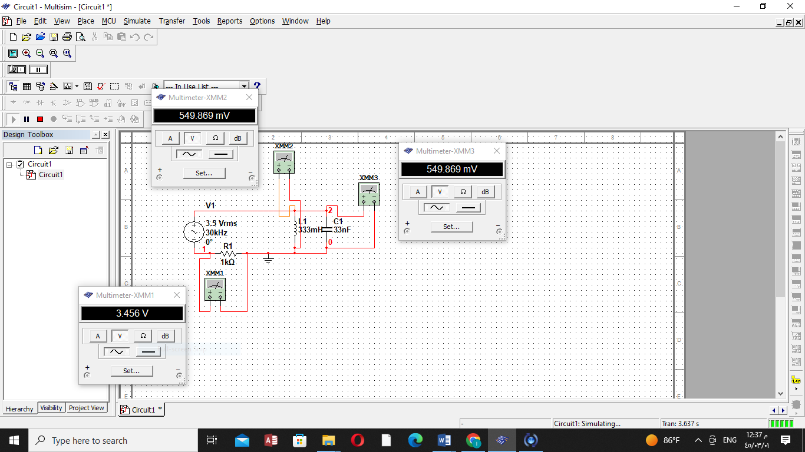

**Vin:**

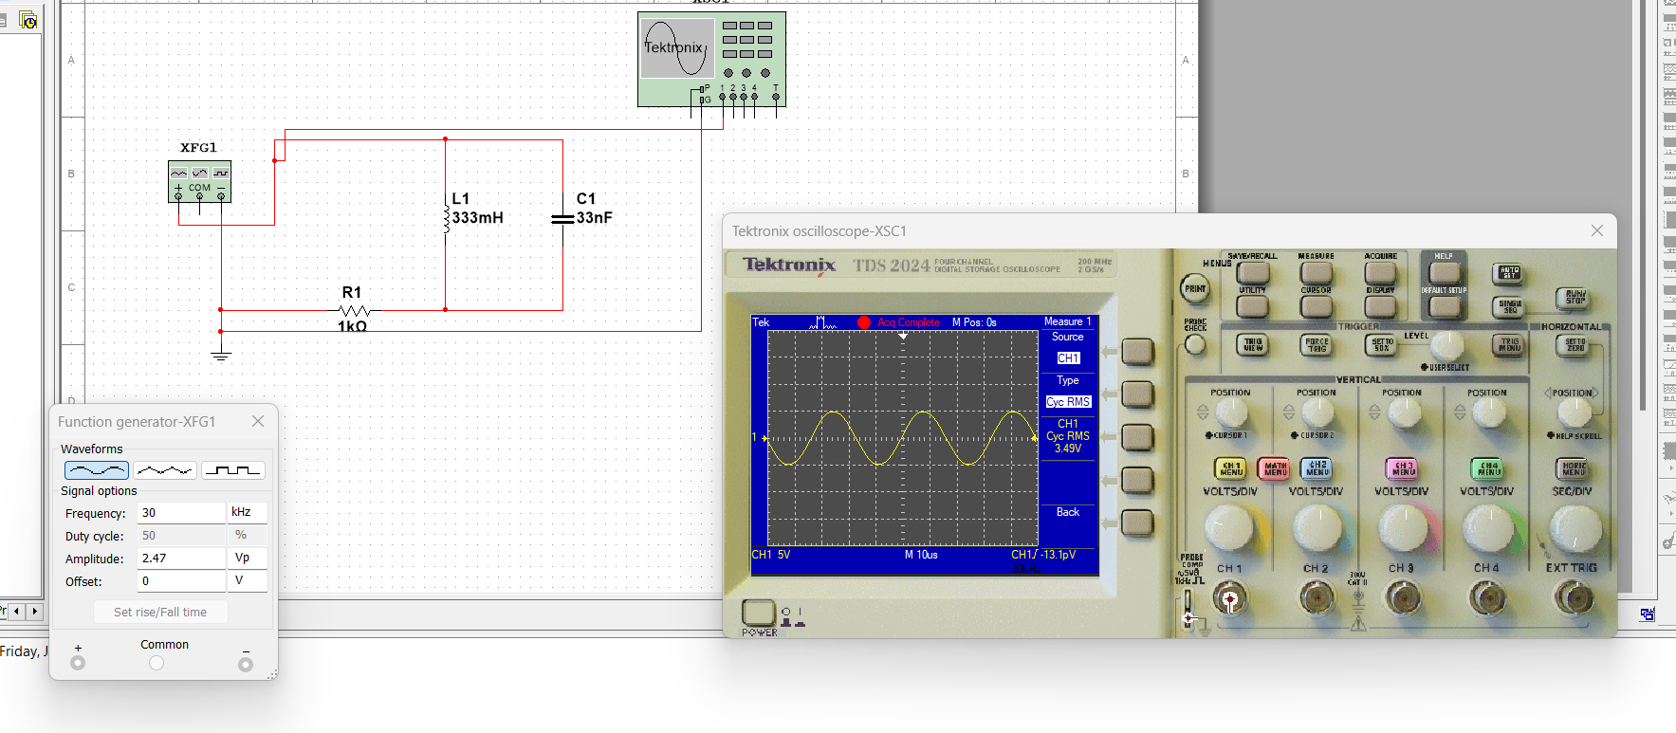

**VR:**

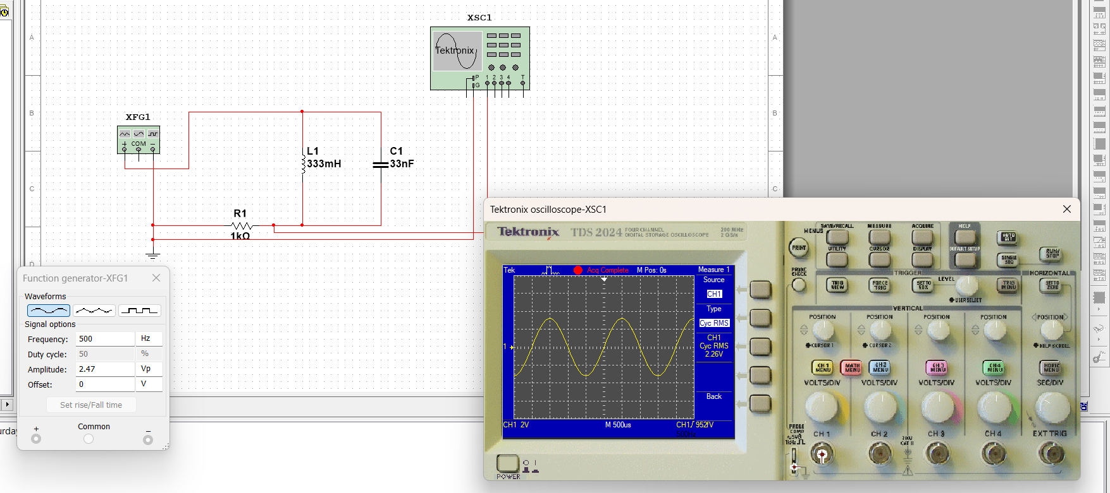

**VC:**

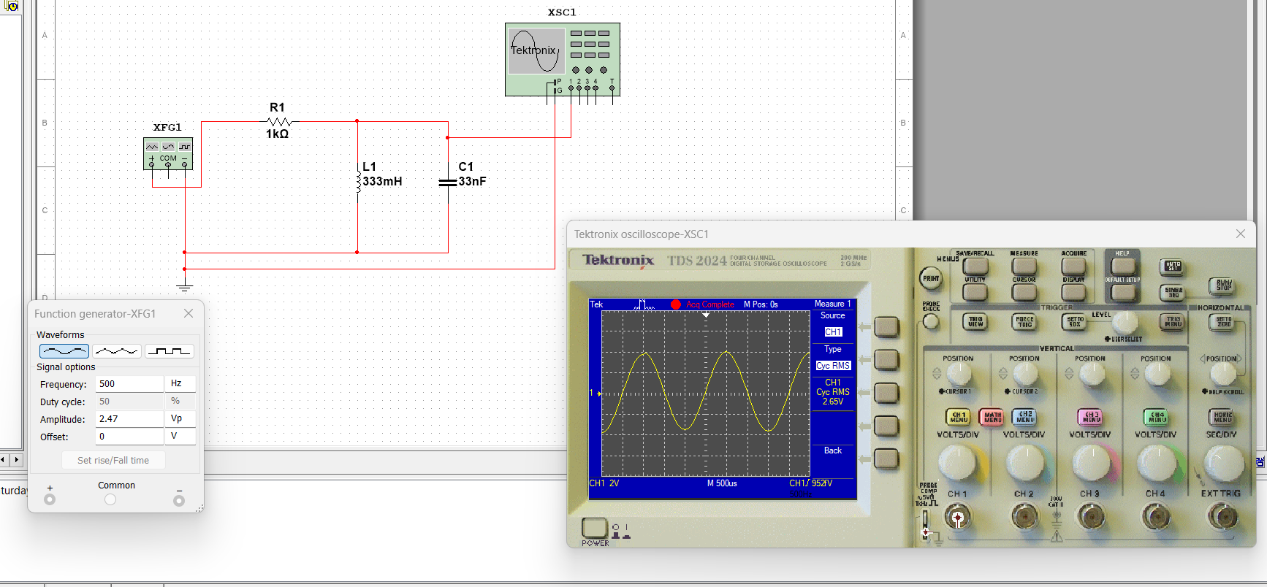

**VL:**

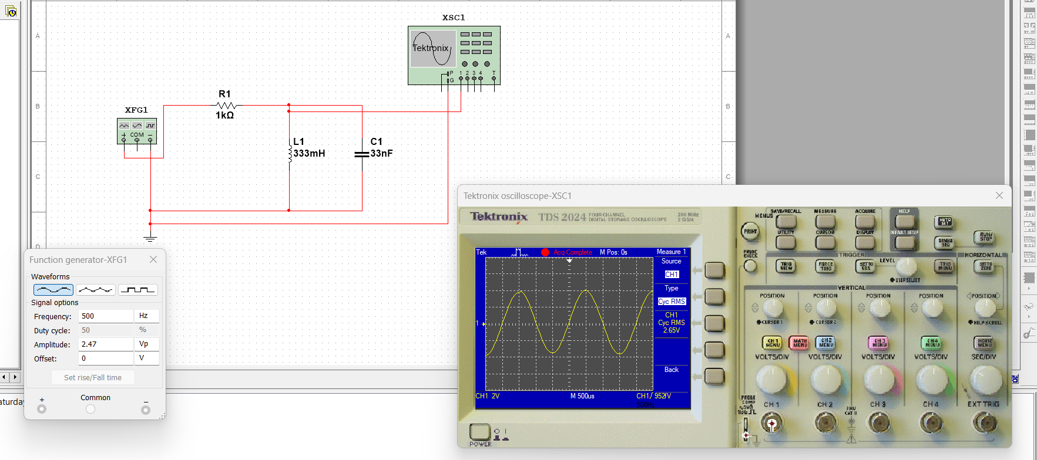

***Conclusion and Analysis:***

1. Discuss the behavior of the circuit based on the results in tables (1,2,3 and 4).

**In table 4 the voltage for C and L equal because it connected in parallel and when we change the frequency the values of voltage change such that the value of vin will remain the same as we are increasing the frequency, but the voltage of C and L decreasing contrast with the value of R which increasing as the frequency increasing.**

**In table 3 Vin do not change when we change the frequency, but the voltage of R decreasing contrast with voltage of C and L.**

**In table 2 when we change the frequency Vin do not change but when the frequency increase the VR decries and the VL increase.**

1. Write down a comprehensive conclusion to sum up what you have learnt today.

**In conclusion, the steady-state response and phase angle of a first-order system are pivotal aspects in understanding its behavior. Through analysis, we observe that the steady-state response stabilizes over time, reflecting the system's equilibrium. Moreover, the phase angle provides valuable insight into the time relationship between input and output signals, crucial for system characterization and design. Understanding these properties enhances our ability to model and control first-order systems effectively.**

**Finally, in this experiment we apply RL and RLC (parallels and series) circuits to determine the voltages and the effect of frequency for voltage.**

**Also, noted that→ if the Z increase so the X will be inductor**

**→ if it decreases then the X will be capacitor**

**→ else X will be resistor**